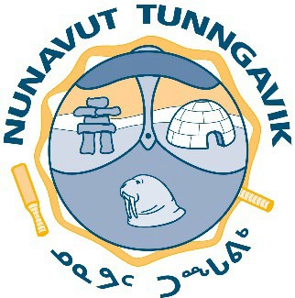
Nunavut Tunngavik Incorporated Board of Directors Meeting Iqaluit, Nunavut
January 21, 2026

AGENDA
- Call to Order
- Housekeeping
- Welcoming Remarks
- Approval of Agenda… R

- Approval of Previous Minutes R
- Hockey Helps the Homeless Funding… R
- Enter In-Camera R
- End In-Camera… R
- Other Business (if any)
  - Next Meeting Dates - March 24-26, 2026 (Location to be determined)
  - Closing Remarks
- Adjournment R

Information/Update Items: | - Quorum Information  - Master Calendar

